KUBERNETE TASK-06

- Create a ConfigMap from a directory containing multiple files and inject the variables into a pod as environment variables.
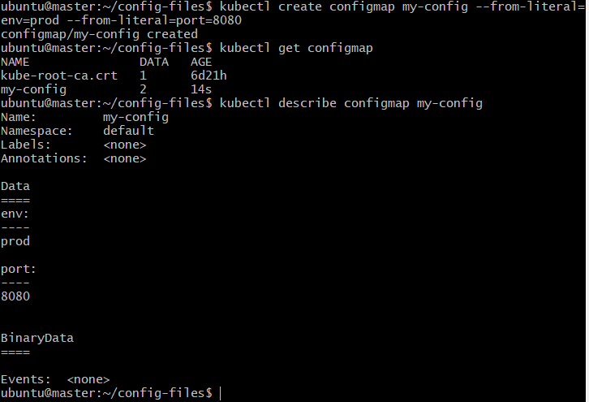
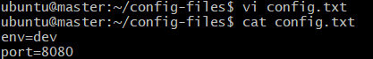
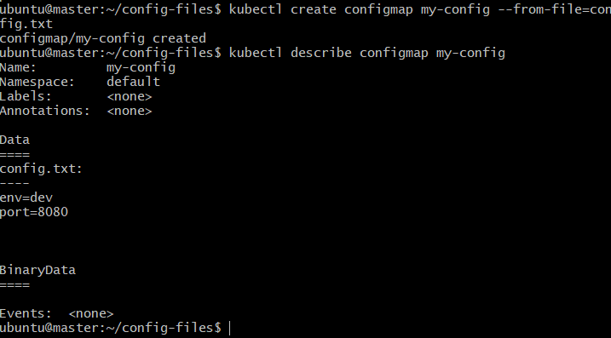
- Create a ConfigMap from a file and mount it as a volume inside a pod, ensuring the configuration data is available as files.
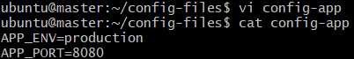
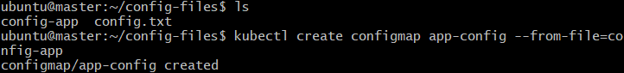
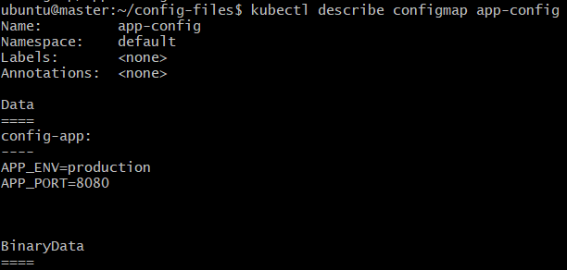
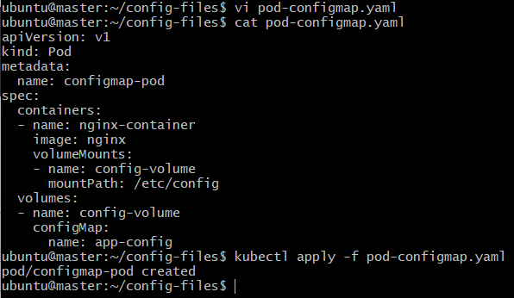
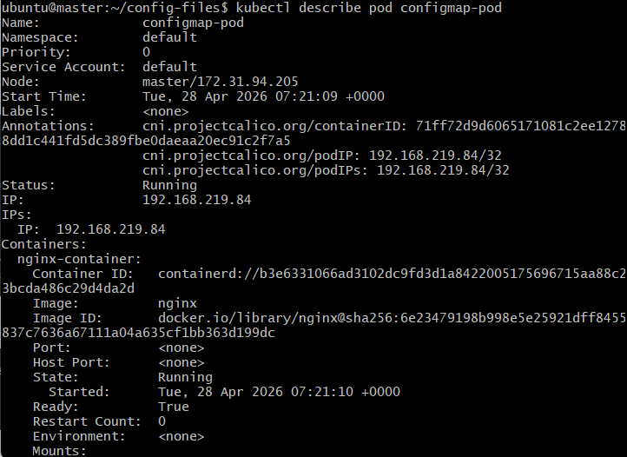
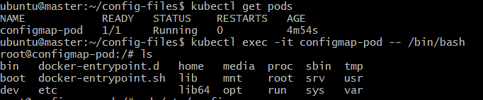
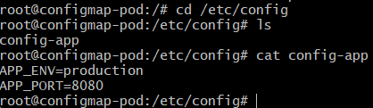
- Create a Secret with sensitive information (username and password) and inject it into a pod as environment variables.
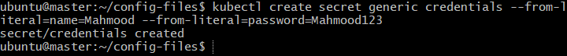
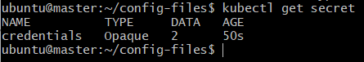
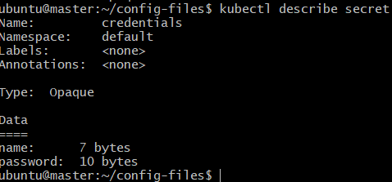
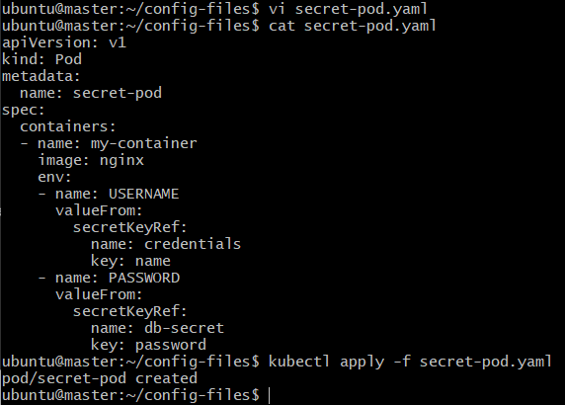
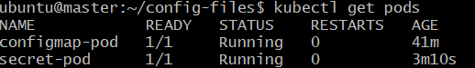
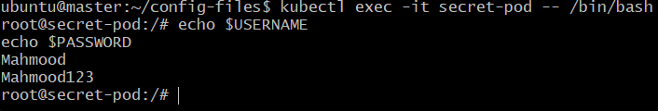
- Create a Secret using a YAML file, mount it as a volume in a pod, and verify the specific Secret values are available as files.
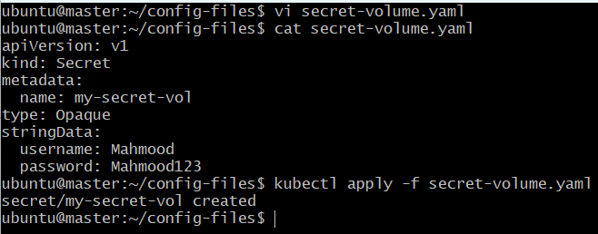
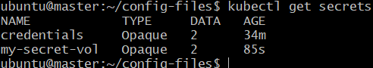
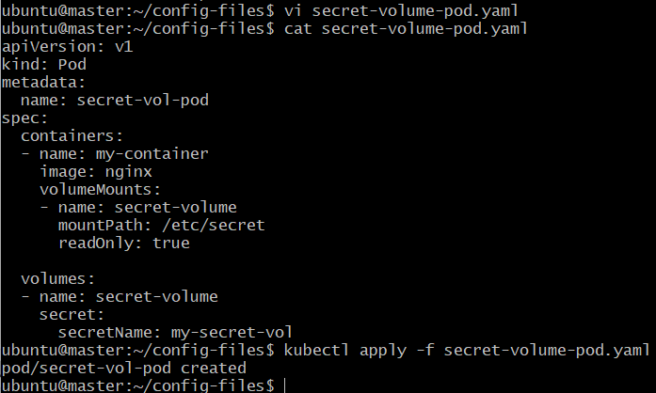
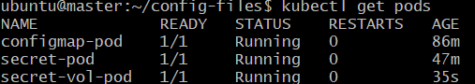
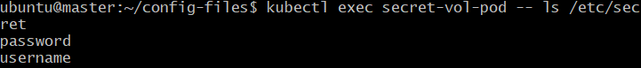
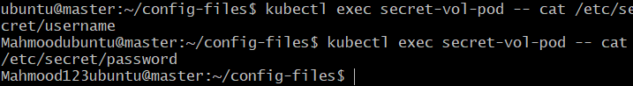
- Inject a ConfigMap as environment variables and a Secret as files into the same pod, ensuring both are accessible within the pod.
